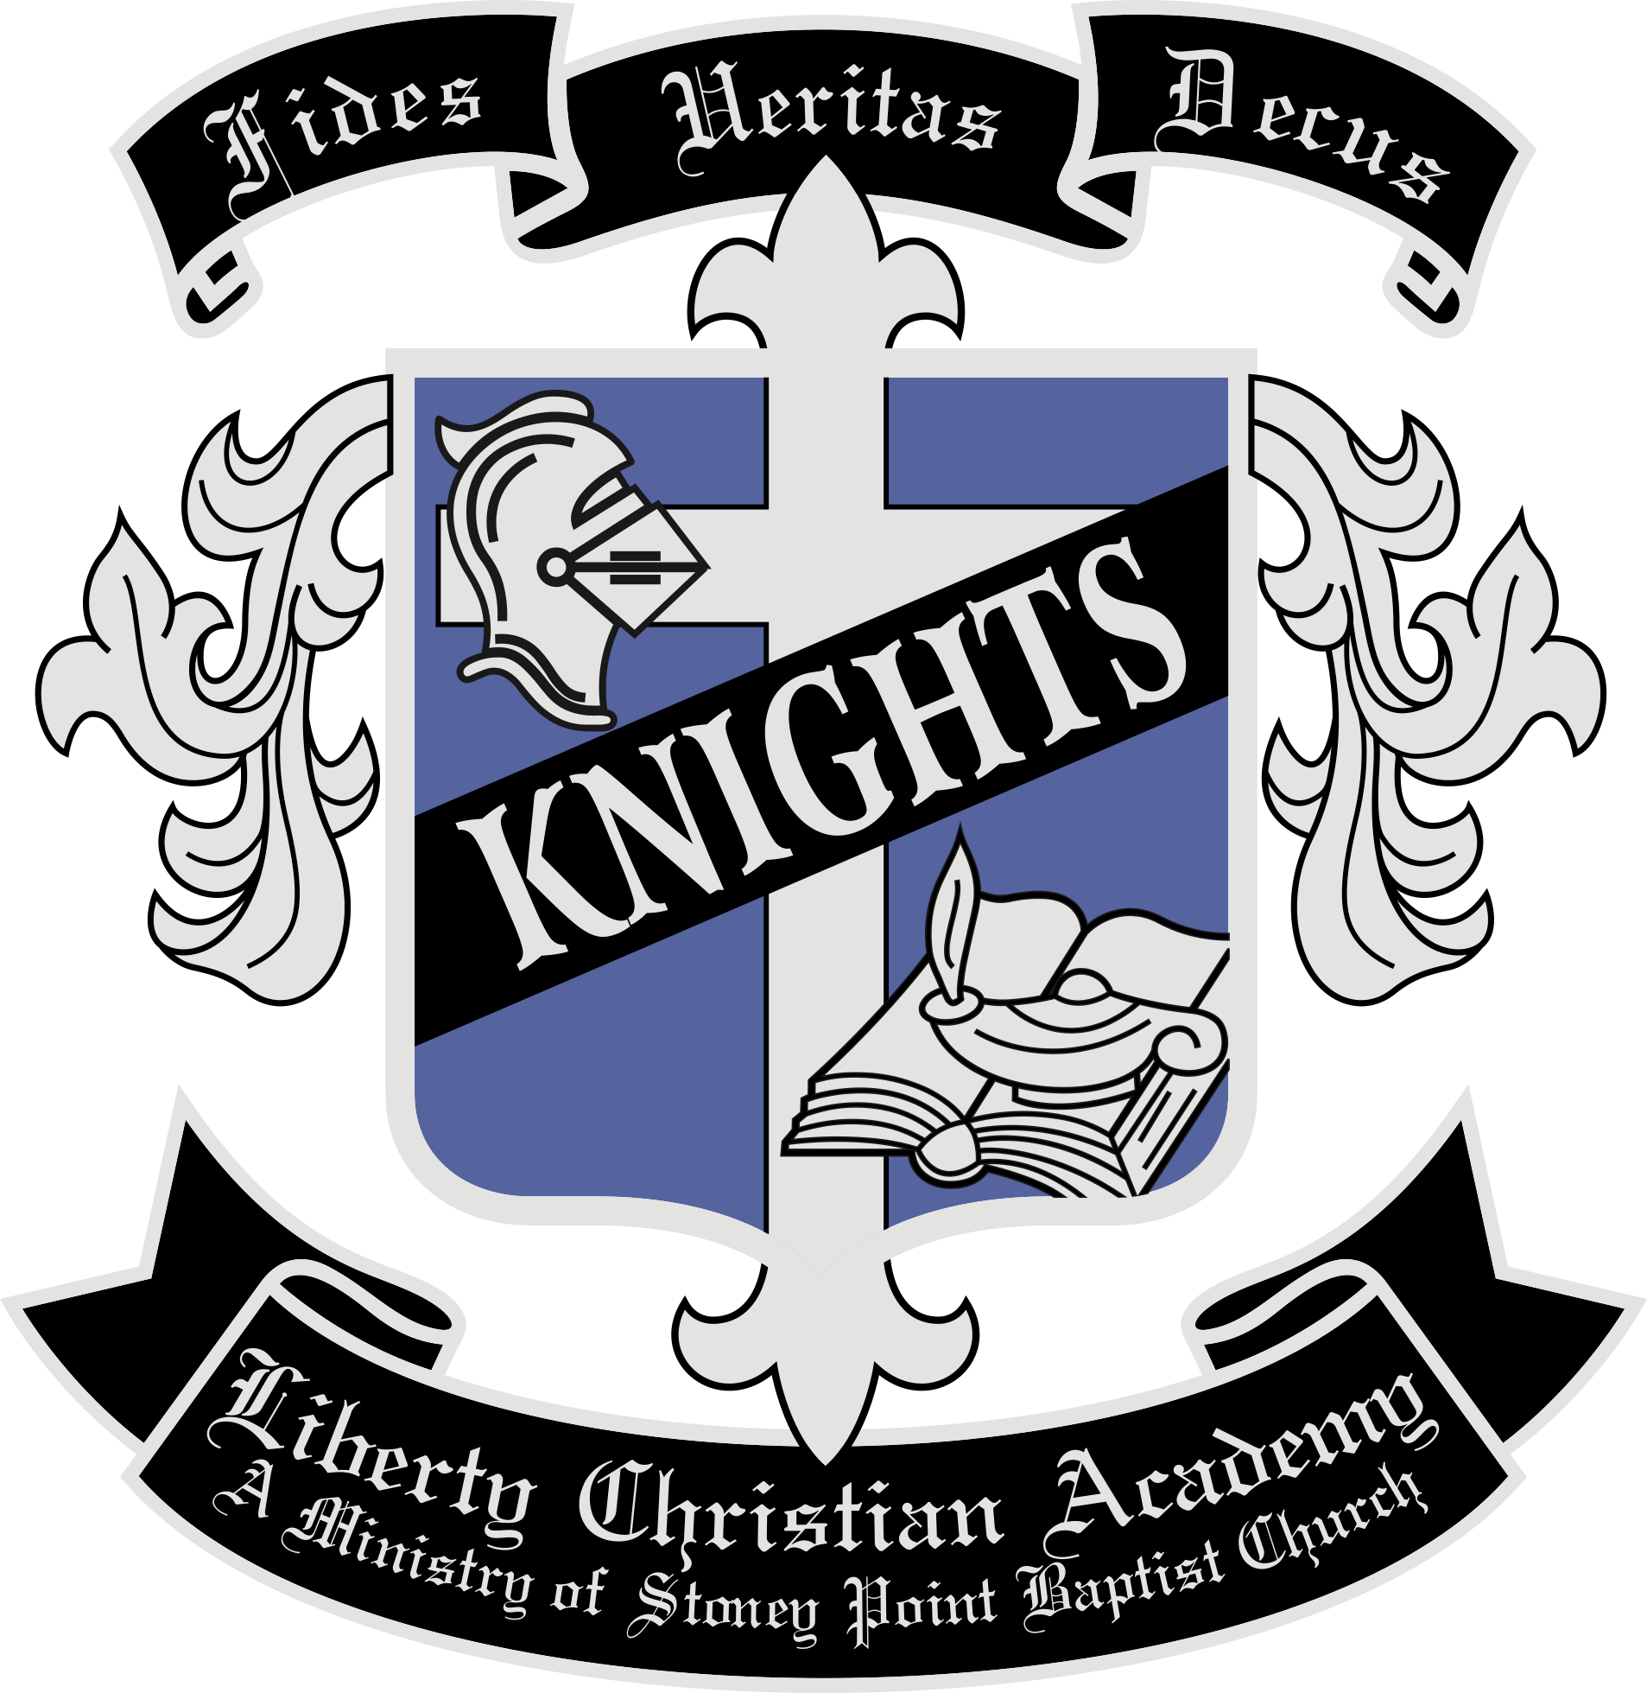
Student Name ________________________________ Grade_________
Phone (______)_______-_________ Date __________
Paid _________ Balance ________
CC __________ Cash _________ Check __________
Liberty Christian Academy

Uniform Order Form

Short Sleeve Polo
Color | YXS $20 | YS $20 | YM $20 | YL $20 | YXL $20 | AS $23 | AM $23 | AL $23 | AXL $23
Royal
Oxford Grey
Black

*Long Sleeve Polo (*While Supplies Last)
Color | YXS $20 | YS $20 | YM $20 | YL $20 | YXL $20 | AS $23 | AM $23 | AL $23 | AXL $23
Royal |  | NA |  | NA | NA
Oxford Grey | NA | NA | NA | NA | NA
Black |  | NA | NA | NA | NA

Cardigan
Color | YXS $25 | YS $25 | YM $25 | YL $25
Black

Crew Sweatshirt
Color | YXS $25 | YS $25 | YM $25 | YL $25 | YXL $25 | AS $28 | AM $28 | AL $28 | AXL $28
Royal
Black

Hooded Sweatshirt
Color | YXS $25 | YS $25 | YM $25 | YL $25 | YXL $25 | AS $28 | AM $28 | AL $28 | AXL $28
Royal
Black

Zip-Up Sweatshirt
Color | YXS $25 | YS $25 | YM $25 | YL $25 | YXL $25 | AS $28 | AM $28 | AL $28 | AXL $28
Royal
Black

Size Guide: YXS (4-5) YS (6-8) YM (10-12) YL (14-16) YXL (18-20)
Additional Sizes Available Upon Request

Over
PE Uniform (Grades 7-9 only)
Color | YXS $12 | YS $12 | YM $12 | YL $12 | YXL $12 | AS $12 | AM $12 | AL $12 | AXL $12
Top
Bottom |  |  |  |  | NA

Beanies Qty
Royal Solid $12
Royal/Gray/Pom $15

Additional Items Qty
Drawstring Bag $18

